PAYMENT METHODS
For national students;
- Payment will be made by credit card and debit card via https://unisis.fbu.edu.tr/ whole at once.
- There will be no installment options.

For international students;
International students can make their summer school tuition fee payment by wire transfer/eft to our university USD accounts specified below.

BUYER NAME: | FENERBAHÇE ÜNİVERSİTESİ
THE NAME OF THE BANK: | VAKIFBANK
IBAN USD | TR74 0001 5001 5804 8023 7883 62
SWİFT | TVBATR2A
RECEIPT DESCRIPTION | Student Number + Student Name and Surname Tuition Fee ÖĞRENCİ NO - ÖĞRENCİ AD SOYAD )

BUYER NAME: | FENERBAHÇE ÜNİVERSİTESİ
THE NAME OF THE BANK: | GARANTİ BANKASI
IBAN USD | TR79 0006 2001 6080 0009 0979 10
SWİFT | TGBATRIS
RECEIPT DESCRIPTION | Student Number + Student Name and Surname Tuition Fee (ÖĞRENCİ NO - ÖĞRENCİ AD SOYAD )

*** IMPORTANT NOTE: Cash and physical POS payment will not be accepted.

PAYMENT STAGES (Detailed explanation)
To make online payment;
https://unisis.fbu.edu.tr/ Click here.
*Login to the following screen with your student e-mail address and password.
*Below, the process stages are explained with a sample student.

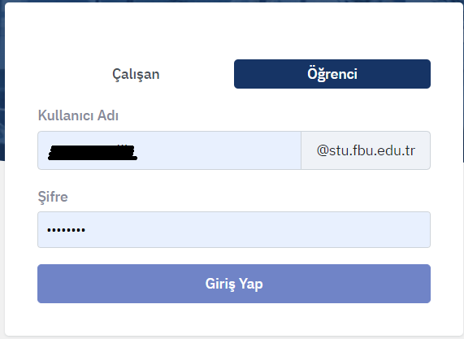

*Click on ‘Ödeme Ekle’ to pay by credit card on the following screen that appears after logging in.

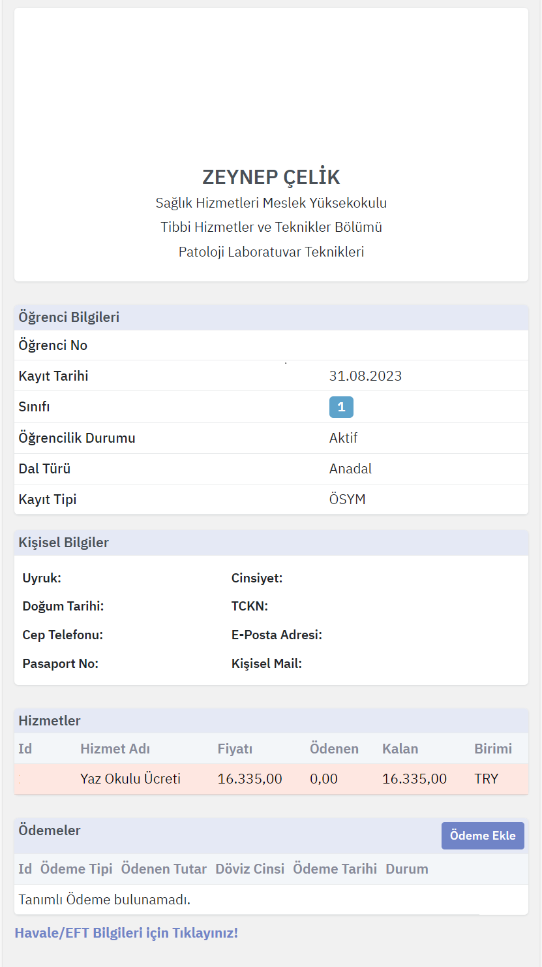
*When you click the Add Payment button, the amount to be paid will automatically appear on the screen below, then click OK.
*When you click the OK button, the system will direct you to the credit card payment screen and you can enter your credit card / debit card information and complete your payment.
